SYSTEM DESIGN
3.1 UML Diagrams:-
UML stands for Unified Modeling Language. UML is a language for specifying, visualizing and documenting the system. This is the step while developing any product after analysis. The goal from this is to produce a model of the entities involved in the project which later need to be built. The representation of the entities that are to be used in the product being developed need to be designed.
There are various kinds of methods in software design:
They are as follows:
- Use case Diagram
- Sequence Diagram
- Class Diagram
- Activity Diagram

3.1.1 Class Diagram
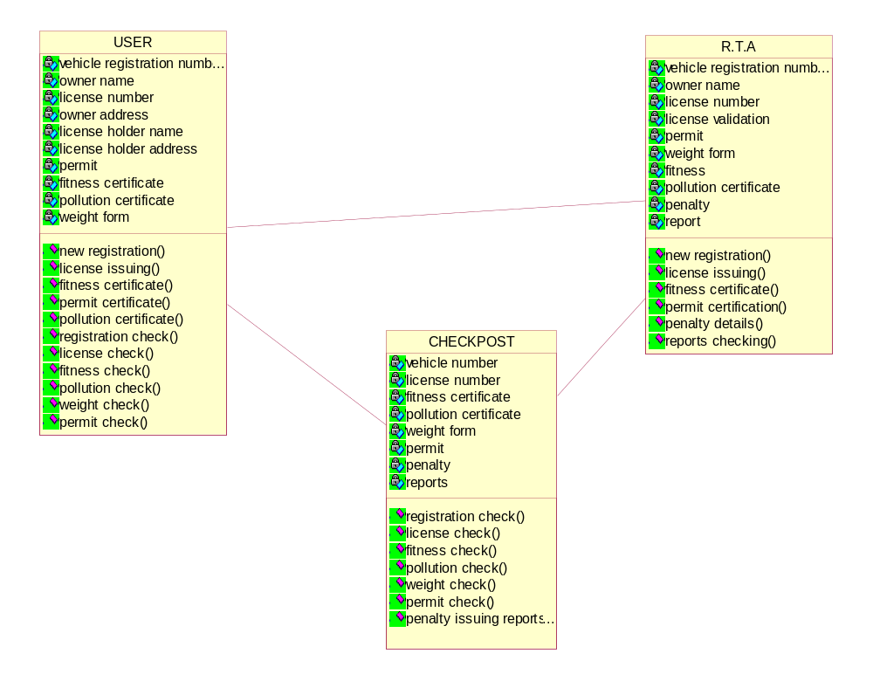
Figure:3.1 Class Diagram
3.1.2 Use Case Diagram
A Use case is a description of set of sequence of actions. Graphically it is rendered as an ellipse with solid line including only its name. Use case diagram is a behavioral diagram that shows a set of use cases and actors and their relationship. It is an association between the use cases and actors. An actor represents a real-world object. Primary Actor–Sender, Secondary Actor Receiver.
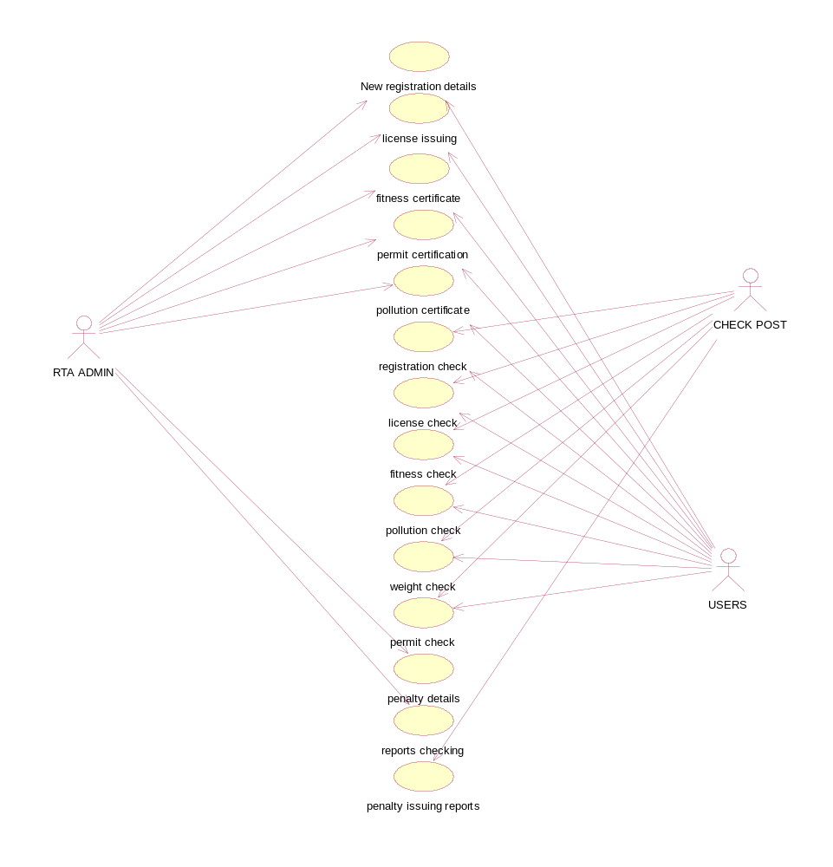
Figure:3.2 Use Case Diagram
3.1.3 Sequence Diagram 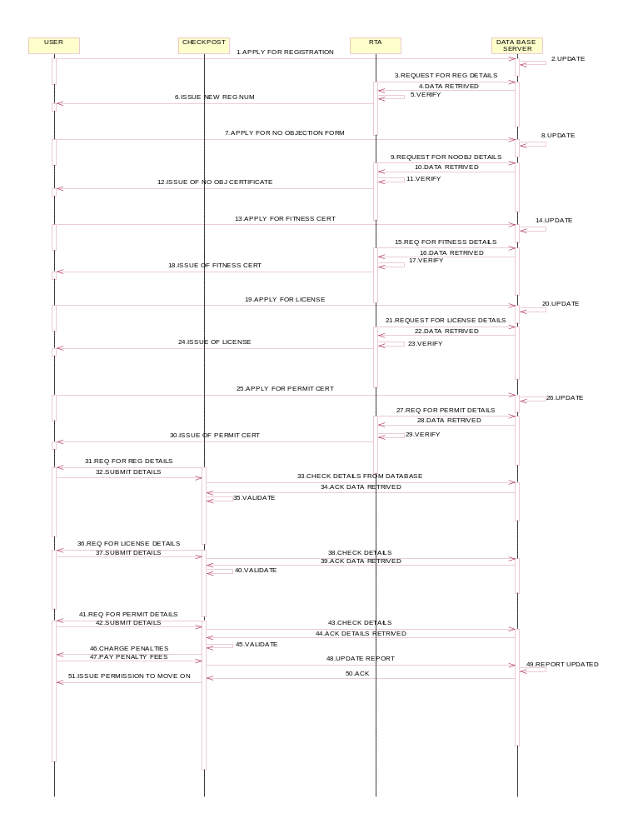
Figure: 3.3 Sequence Diagram
3.1.4 Activity Diagram:-
CHECK-POST ACTIVITY DIAGRAM:-
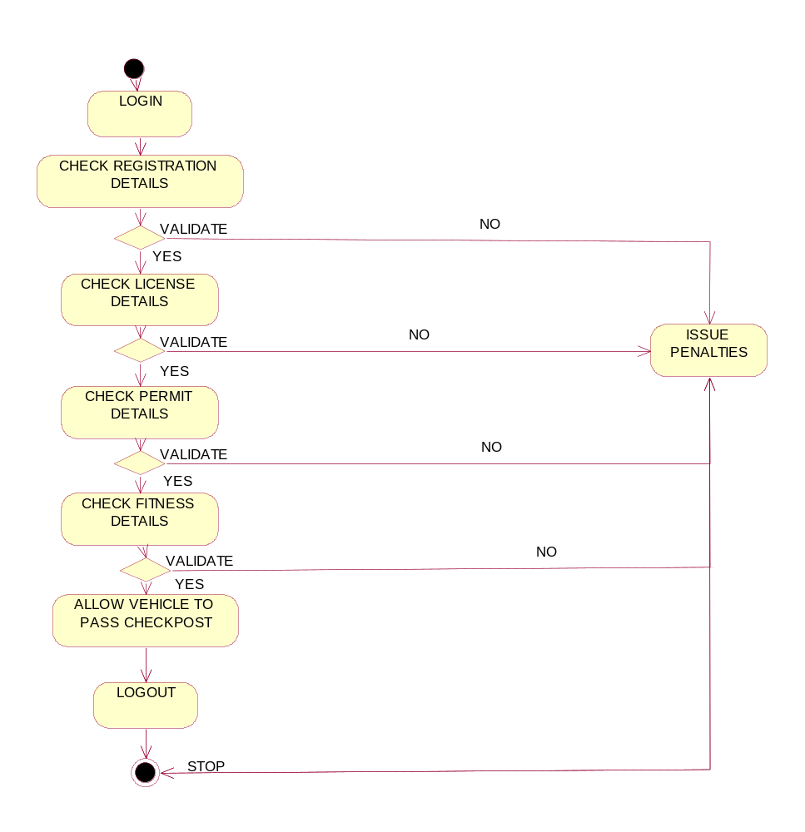
Figure:3.4 Activity Diagram of check-post

3.5 RTA ACTIVITY DIAGRAM:
